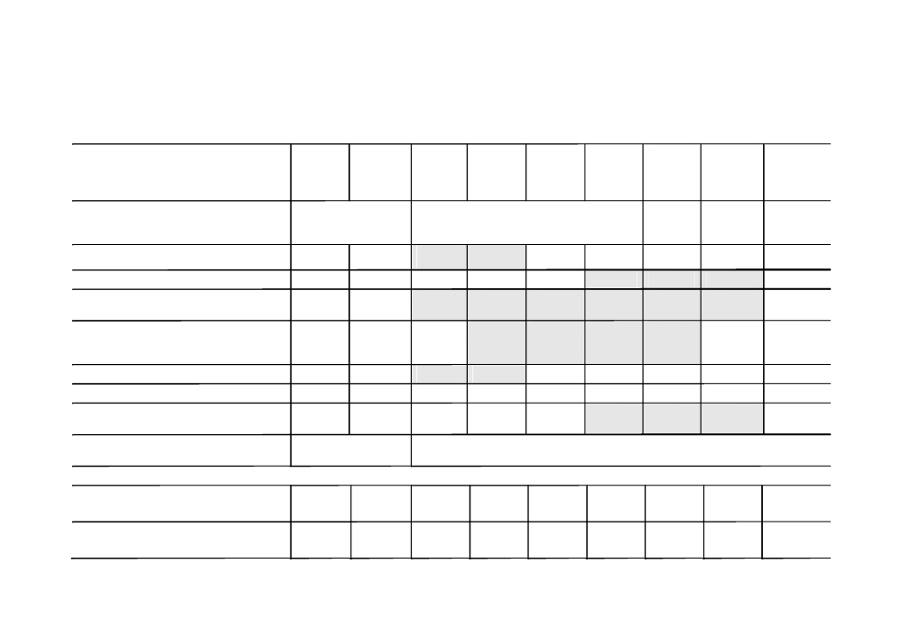

TIME LINE FOR IMPLEMENATION OF BASEL III / BASEL 3
Phase-in arrangements
(shading indicates transition periods - all dates are as of 1 January)

2011 2012 2013 2014 2015 2016 2017 2018 As of
1 January
2019

Leverage Ratio

Supervisory monitoring

Parallel run
1 Jan 2013 - 1 Jan 2017
Disclosure starts 1 Jan 2015

Migration to
Pillar 1

Minimum Common Equity Capital Ratio 3.5% 4.0% 4.5% 4.5% 4.5% 4.5% 4.5%

Capital Conservation Buffer 0.625% 1.25% 1.875% 2.50%

Minimum common equity plus capital
conservation buffer

3.5% 4.0% 4.5% 5.125%

5.75% 6.375%

7.0%

Phase-in of deductions from CET1

(including amounts exceeding the limit for 20% 40% 60% 80% 100% 100%

DTAs, MSRs and financials )

Minimum Tier 1 Capital 4.5% 5.5% 6.0% 6.0% 6.0% 6.0% 6.0%

Minimum Total Capital 8.0% 8.0% 8.0% 8.0% 8.0% 8.0% 8.0%

Minimum Total Capital plus conservation
buffer

8.0% 8.0% 8.0% 8.625%

9.25% 9.875%

10.5%

Capital instruments that no longer qualify
as non-core Tier 1 capital or Tier 2 capital

Phased out over 10 year horizon beginning 2013

Observation Introduce

Liquidity coverage ratio period minimum

begins standard

Observation Introduce

Net stable funding ratio period minimum

begins standard

